Configure Tomcat and setup Development Environment

To have the code compiled and working in Tomcat, go to the below URL:
https://confluence.sakaiproject.org/display/BOOT/Development+Environment+Setup+Walkthrough

Note: All the related installable exe, zip files, Sakai source code and properties file are kept in server, no need to download.

Follow the below steps:
- Step 1 - Install Java
- Step 2 and 3 - Install MySQL and DB Setup – can be done later
- Step 4- - Install Maven
- Step 5 – Skip for now
- Step 6 – Setup Tomcat
- Step 8 – Take the source code from server src-2.9.x-all
- Step 9 and Step 10 – Do it

Note: At this point, make sure that you have setup all the environment variables correct!

- Step 11 (Maven Build commands) – In command prompt, go to the source directory in your local and execute the below:
    - cd master
    - mvn clean install
    - cd..
    - mvn clean install sakai:deploy -Dmaven.tomcat.home=C:\tomcat (Your Path)
This will take hours together to run, please be patience enough….
- Step 12 – MUST be working out for you now!
You must be able to see your http://localhost:8080/portal up and running
If yes, continue. If no, check all the above steps once again!

- Step 13,14 and 15 – Do it
- Step 16 – Follow a, b, till h – i
During the Step 16, h, ii - Do not import all the packages in to eclipse rather do import only the packages that you are working on. If you are seeing any build errors for the imported packages, go ahead and import the dependent packages shown in the build error. Make sure that there are no build errors!

Configure Debugging Tomcat with in eclipse

Follow Configuring Tomcat as a Known Server from within Eclipse steps in the below link
https://confluence.sakaiproject.org/display/BOOT/Debugging+Tomcat+Remotely+Using+Eclipse

In server setup choose the second option in server location and also Increase the server Timeouts for startup and stop. For e.g., 900 and 700

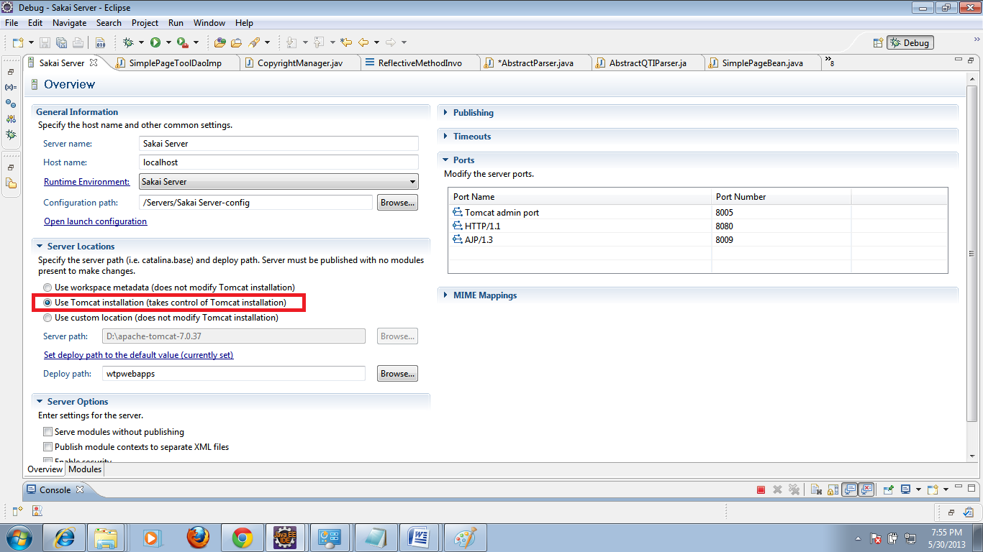

Do the below step as well:

1. Goto Windows->Preferences
2. Select Java-> Installed JRE in left Panel
3. Single-click the desired run-time, then click "Edit".
4. Give the JDK path in JRE Home Textbox

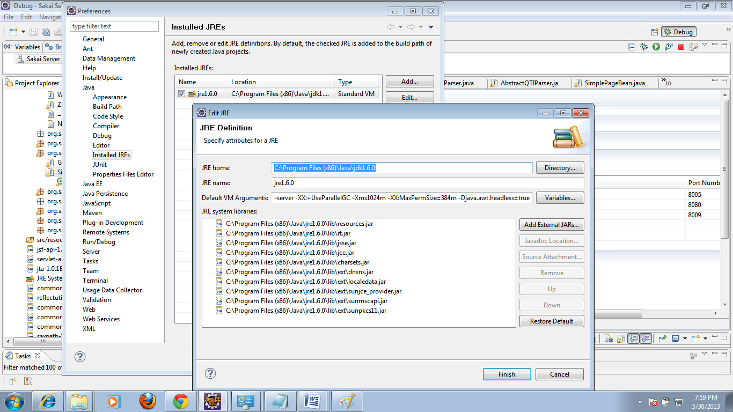

So start Tomcat from inside eclipse - In explorer go to your screen - keep break points in any of the java functions that you would think that its going to be called now... Eclipse will blink/will highlight that line and wait for you to proceed further!

Now enjoy with F5, F6, F7 and F8.

Configuration Steps to view Database Commands in the Eclipse console

1. Open Tomcat folder
2. Navigate to Sakai folder
3. Open Sakai Properties file
4. Change hibernate.show_sql from False to True

While running server, in the console, all the SQL commands will be displayed for a particular page/operation.
Reflect Your Code In the Server;
Now the interesting part, if you want to do any changes says in your jsp/ java file, do the change in eclipse, save, do build.
Go to command prompt, inside your package in the source code
C:\sakaisource>cd urpackagename
C:\sakaiSource\urpackagename>mvn clean install sakai:deploy -Dmaven.tomcat.home=C:\tomcat (Your Path)

This will put all your new classes in tomcat webapps.

Now go and access your page in browser, you can see your changes!

Happy Coding ☺

